Updated: 9th April 2020

Free School Meals Entitlement – Supermarket Vouchers - Frequently Asked Questions.

Why is the Council issuing supermarket vouchers?
We are living through difficult times and in so far as is possible we all have to play our part by limiting social interactions to prevent the spread of the Coronavirus and to keep people safe. The Council have identified vouchers as a way of providing funds to ensure those children who are entitled to a free meal are able to have one and they are working with a company called Wonde to ensure that those who are entitled to a voucher get it quickly.
How do I get the vouchers?
The first time you receive a voucher you will receive an initial email or text from Wonde that looks like this and it will state the name of your child’s school. You will be asked to select the supermarket of your choice. Click or touch the link (in blue type) to do this.
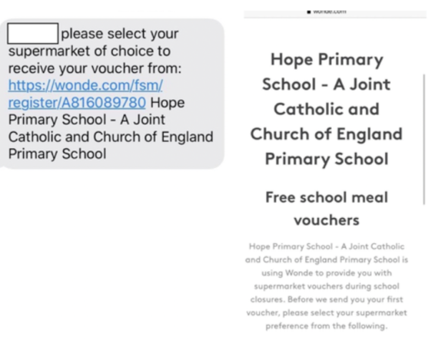

Once you have done this you will receive a follow up message that will look like this:
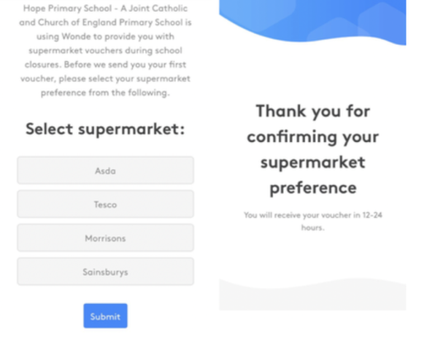
Now select your supermarket from the list shown and then click or touch the SUBMIT button (in blue on the screen).
Your vouchers should then arrive by email or text within the next 24 hours. If they don’t arrive by 48 hours please contact your child’s school BUT do ensure that you have followed the steps set out above and have selected a supermarket.
Once you have selected a supermarket you will be sent a voucher link from Wonde. You simply click on this link to display the voucher which you present at the supermarket of your choice when you are paying. You can present the voucher on your smart phone or portable device or if necessary you can print it off.
I have selected my supermarket choice but still haven’t received my voucher – why is this?
Using this method to issue vouchers has proven to be efficient and secure. Once you have made your supermarket choice Wonde make an order with the supermarkets and vouchers are despatched. Every effort is made to despatch vouchers quickly but you must appreciate there is a lead time to ordering and processing the vouchers. Vouchers are normally delivered within 24 hours but it may take up to 48 hours from families selecting the supermarket choice to receiving the vouchers.
How will families know that the communications they receive from Wonde about this are legitimate and not a scam?
The communication from Wonde will initially ask families to select a preferred supermarket to use the voucher in. Wonde will not ask families to send any personal details as part of their communication with them. Any unsolicited approach asking for personal information should be treated with suspicion. You can get useful information at www.citizensadvice.org.uk
I haven’t been contacted by Wonde about my supermarket preference – why is this?
If you believe your child is eligible for free school meals and haven’t received the initial text or email from Wonde, the most likely reason for this is that the school does not have your correct contact details. You should contact the school as soon as possible to confirm they have an up to date mobile telephone number or email for you.
I have more than one child but they go to different schools – will I get more than one voucher?
Knowsley have chosen to work with Wonde to issue vouchers so if you have more than one child and they go to different schools but in Knowsley, each school will administer the process but using Wonde. You will therefore be contacted more than once by Wonde but each contact will state the name of the school. If you have a child that goes to a school outside of Knowsley the process may be different and you should contact the school for information.
I don’t have a smart phone or mobile device – what can I do?
If families are unable to access a voucher on a smart phone or email they can forward the message to a family member who can register them on their phone.
In the rare event that a family is unable to access the voucher online an alternative arrangement will be made but this will be on a case by case basis. You will need to contact your child’s school to discuss this and it may delay the process of getting the voucher to you.
Where can I spend the vouchers?
You can opt to spend the vouchers in Asda or Sainsburys or Morrisons or Tesco. You must select one supermarket from this choice of four when you are contacted by Wonde. Other supermarkets may become part of the scheme shortly. You can use the voucher in a different branch of your nominated supermarket, but you cannot use it in a different supermarket to the one you have selected.
Can I change my supermarket preference?
Currently not, but this may change in the future. Once you have selected a supermarket preference this will be used for future allocations of vouchers.

Can I use the voucher to shop online?
No, you must spend the voucher instore – it is not possible to use them for online shopping at the present time. You must present the voucher when making payment.
Are there any restrictions on what the vouchers can be used for?
The vouchers are designed to be spent on essential food items and are provided to purchase a replacement for the healthy meal children would usually receive in school. They must not be used for any other purpose.
When will my vouchers arrive?
Knowsley schools have already issued vouchers to eligible families to cover the period from 30th March to the 13th April 2020 and are in the process of issuing vouchers to cover 13th April to 24th April 2020.

How much will I get?
You will receive a single voucher to cover the applicable period so it is important that you plan and use your voucher carefully. For the two week period starting on 13th April 2020 Knowsley have matched the funding allocation directed by the Government which equates to £3 per day, therefore £15 per week and £30 for a two week period.

Do I have to spend them all in one go?

No. The voucher can be used over multiple shops until the total amount has been used.
What happens if I don’t use the voucher immediately?
The voucher retains its value until the date it is due to expire and this varies according to the supermarket terms and conditions (please check the supermarket website for details) but as a minimum the voucher will have a lifespan of 12 months. However, parents are expected to use these vouchers within a very short window (i.e. days/weeks).
I haven’t received my vouchers – who do I contact?
If you have been contacted by Wonde to choose a supermarket and you have made a selection and submitted it, you should receive your voucher. If you believe that your child is eligible for free school meals and haven’t received the initial text or email from Wonde, the most likely reason for this is that the school does not have your correct contact details. You should contact the school as soon as possible to confirm they have an up to date mobile or email for you.
Schools are working hard to make sure vouchers are issued promptly but please be patient if there is a slight delay and it is always worth checking for updates on the school website. If you need to speak to someone you should contact the school office.
My child gets a free lunch under the Universal Infant Free School Meals Offer – will I get a supermarket voucher?
The Government scheme launched on Tuesday 31st March only applies to benefit entitled free school meal families. However, Knowsley will be issuing vouchers to families entitled to a meal under UIFSM for a further two week period commencing 13th April 2020. Knowsley will communicate out to families in receipt of UIFSM entitlement if this is to change after the 24th April 2020.

My child doesn’t get free school meals but I think they should – what should I do?

If you think your child is eligible for a free school mean and isn’t receiving it you should apply to the Council by completing a Free School Meal form which is available on the Council’s website at www.knowsley.gov.uk. The completed form can be emailed to benefits@knowsley.gov.uk or posted to Knowsley MBC, Benefits Section, Municipal Buildings, Archway Road, Huyton L36 9YU.
I’ve heard something about the Government introducing a voucher scheme – will I get vouchers from the government as well as the school?
No. The Wonde system is, at present, Knowsley’s chosen method for providing vouchers to families who would normally be in receipt of a free school meal. Should Knowsley choose to change its approach to providing families with vouchers this will be clearly communicated out by both Knowsley Council and your child’s school.
Is there a cost to this for the families?
No, there is no cost to the families.
I have a question but my child’s school is closed – who do I contact?
All queries should be directed to your child’s school by telephone and if this is unsuccessful then by email to the school. Wonde have also published guidance and this can be viewed at http://help.wonde.com/en/articles/3843162-faqs-for-parents-supermarket-voucher. This guidance will be kept under review and changes will be made as necessary.
Please remember, schools and the Council are working very hard to ensure that this process works efficiently but please be patient while we all do our very best to cope in what are extremely challenging circumstances.

