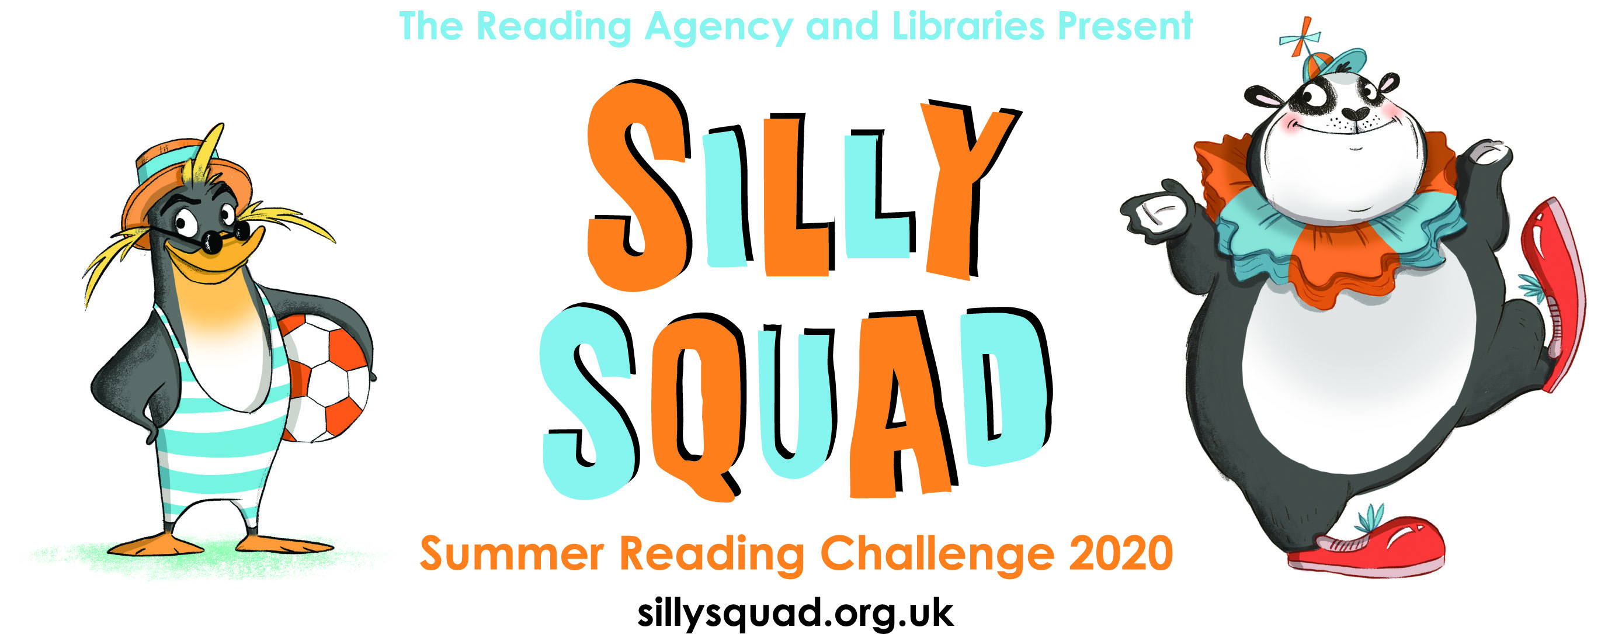

F.A.O. Headteacher / Literacy Co-ordinator

Summer Reading Challenge 2020 – ‘Silly Squad’

This has been a year like no other and we’re all adjusting to the necessary changes in the way we live. This year, the Summer Reading Challenge is available for children on-line but for those children who cannot access this offer we are continuing to run the Summer Reading Challenge through the Public Library Service. We feel that this is vital to help children maintain their reading skills and confidence. It’s about children enjoying what they read and discovering more about books.

The Challenge this year is called ‘Silly Squad’. Aimed at 4 – 11 year olds, the Challenge is simple: to read five or more library books over the summer. Every child completing the challenge will receive a certificate and medal.

As well as encouraging reading, there are additional benefits for participating children and schools:

- The Challenge links in with 3 Key Themes of the Reading Quality Mark (Reading Promotion, Reading Events and Groups, and Family/Community involvement through the Public Library Service)
- The school with the most Challenge completers will be awarded a fantastic trophy to keep (runners-up will also receive a trophy).

We would love it if you could promote this year’s Summer Reading Challenge to the children and parents of your school.

Huyton Library will be offering a ‘Select & Collect’ service from Monday 13th July.

Simply contact the library on 443 3734 to request some books and a Summer Reading Challenge pack and we will arrange a date and time for you to collect them at the library door.

With our very best wishes for a lovely summer holiday.

Gerry Williams
Senior Librarian: Children and Young People
Tel: 0151 443 5001



